 

Western University Faculty of Engineering

Studio Section 28 – Joseph Santarelli

Team Identifier: 28Inhal

Team Members: Kangmengjie Wu, Krishna Gowda, Leo Wallner, Xristopher Aliferis, Anthony Garant, Ali Masood

28 Inhaler Counter

An inclusive, modern approach.

Table of Contents:

1 Need / Challenge 3

2 Final Design Documentation 3

3 Testing and Validation 6

3.1 Compliance Matrix: Constraints 6

3.2 Objectives Evaluation 8

4 Comparison 10

4.1 Comparison 1 10

4.2 Comparison 2 11

5 Potential Improvements 11

6 References 12

7 Appendix A – Examples of Design Documentation 12

7.1 Flowchart 13

7.2 CAD Models or Drawings 14

7.3 Video demonstration Accurate Counting and Non-disruptive process 15

# Need / Challenge:

Partially sighted users need an easily accessible and independent way to monitor their remaining inhaler dosage due to existing solutions being heavily dependent on visual cues that they lack such as small writing and no colour diversity.

# Final Design Documentation:

Our final design has 3 major components, our circuit, our code, and our case. Below, we describe what each component does, how it works, and how to replicate it. We also have included any necessary information to combine the components and fully assemble our inhaler counter.

1. Our circuit:
   1. Components and their functions

The circuit is made from: a rechargeable 9V Battery, jumper wires, an Arduino pro micro, a Piezo buzzer, a push button, a lead coil, and an 8 by 8 LED light board.

Each component has its own, distinct function. Starting with the 9V battery, its purpose is to provide us with a stable source of power. Our Arduino required 5V at 50 mA. One of the options we had was to use a 5V lithium-ion battery, that is rechargeable using a charging port (Type C or Micro USB). We decided against using this system as it required us to use a charging port board, as well as a battery management system (BMS) board, both of which took up space and required extra wiring and programming. Our decision was to go with a rechargeable 9V system, since they were readily available, and the Arduino could take up to 12V coming from the VCC port. We also gave it a dedicated ground port, instead of sharing it with the other components. The only drawback we noticed is the waste in voltage, as the 9V was being stepped down to 5v using the board’s transformer, which also lead to a change of overheating.

Our second component was the 8 x 8 LED board. At first, we experimented using the original 16 pin module, which helped us control every individual LED. This was effective, but required many digital GPIO pins, which was only applicable using an Arduino UNO due to its size. We then decided to switch to a module that used a MAX7219 IC, reducing the input to just 5 pins (3 of which were digitals). When we included the libraries in our code, it allowed us to reduce the program and wiring complexity.

Our third component was the piezo. Instead of a speaker, we decided to go with a piezo due to our budget and to reduce the voltage draw from the power source. Through our code, we were able to adjust the volume and duration easily, based on the power we send to the digital pin.

Our fourth and main component was the Arduino Micro itself. We decided to go with this computer due to its versatility and efficiency. Our alternative was the Arduino Nano, which had a similar form factor and input voltage. We decided against using this device since it had a lower EEPROM (read only memory essential for storing programs onboard) and the increased number of digital IO pins on the Micro.

Our fifth component was the push button. When deciding the user interface, we found that the push button was the most effective since it is large and easy to identify. Our alternative was using a slider switch or a touch switch. Both options did not seem user friendly since they did not provide the same feedback for the user. This was also programmed to have the piezo buzz when the button was pressed.

Our flow diagram **(7.1)** shows how the circuit interacts with the inhaler, as well as how the code on the Arduino is used to monitor the remaining doses.

* 1. Assembly and troubleshooting

Since our Micro did not have any headers soldered on, we had to individually solder each component. This posed many challenges for us since none of us had significant experience soldering. We also ran into issues with causing short circuits, since the connections were very close to each other and the solder between them easily stuck to each other. Furthermore, we ran into issues with our wiring since we did not have enough ground and 5v ports on the board. As a result, we had to bridge multiple cables, causing more shorts in the circuit. To prevent these shorts, we used electrical tape to properly seal any exposed terminals. For our wiring, we decided to go with jumper cables. In many cases, we had to strip the cables, since they did not easily fit when soldering multiple cables together. In our circuit we used 1 external resistor and used the internal pull-up resister twice. Using the internal resistor helped us simplify the circuit and gave us a more accurate signal pin reading. When we tried to use the circuit without it, slight vibrations in the environment triggered a signal, causing very inaccurate readings. During our wiring process, we decided to go with longer wires, to prevent any stretching of cables. This was a huge mistake that we realized during our final assembly process, since we had a hard time fitting all the wires into our case. This caused our overall circuit to be compact, making it hard to add the lid. We also glued the Arduino to the battery with a piece of open plastic in-between to prevent it from moving. This caused issues when the Arduino ran for long periods of time, as the heat from both devices melted the glue and the Arduino came loose inside the case. For our next prototype, we believe it is beneficial to use a PCB, since it will eliminate the need for all the jumper wires and therefore reducing the case size.

For our inhaler circuit, we tried using a copper coil attached to the canister and a U-shaped baseplate made of aluminum foil and copper wires coiled up together. This system worked for a short period of time, but when we tried to resolder the signal wires, we found that the lead did not stick to the copper wire, making the circuit incomplete in many instances. As a result, we decided to switch the copper to lead wire, since it was much easier to work, as the solder easily stuck to it. This greatly improved our counting accuracy and reduced the number of times the canister jammed inside the inhaler.

In **(7.2.1)** we can see the entire circuit diagram, with the inhaler included, labeled as “canister”. The inhaler section of the circuit uses the lead coil attached via electrical tape to the very bottom of the canister. This coil, when the canister was depressed, touches the U-shaped baseplate and completes this canister circuit for a very short amount of time. The placement of the coil and baseplate is crucial for the counting mechanism to work and be extremely accurate. When assembling this section, we included the buzz for every count to make sure it was clear that the circuit was completed when administering a dose.

1. Programming and logic

The coding process for this project was straightforward once the circuit was completed and fully functional. The first step was inputting all the correct ports from the circuit to our program, as well as including the LedControl.h library file to ensure proper functioning of the 8x8 LED board.

The second step involved setting up the LED by turning it on, adjusting the intensity, and clearing it. Then, we declared the parts of the circuit that were input or output, with the piezo being an output and the canister and button being inputs and specifically using the pull-up resistor. If we had omitted this step, the entire system would have failed to work properly.



The third step was figuring out the loop statement and determining what we wanted each part of the circuit to do specifically, as well as the functionality we wanted to add to the inhaler casing. Firstly, we had to declare a function to constantly read the state of the button and the canister. Following this, we moved into an if statement that checked if the canister was pressed down, and if it was true, it would subtract one puff from the total count and activate the piezo buzzer for 100 milliseconds. After this, there were four important if statements. If the current puff count was between 20%-10%, the entire LED display would turn on. If it was between 10%-5%, half of the display would turn on. If it were at 5% or below, an “X” would be displayed. Lastly, if it was empty, nothing would be displayed, and the piezo would buzz for 3 seconds. Finally, at the end of everything, we would delay for 3 seconds to allow for the release of the canister and to turn off the display.

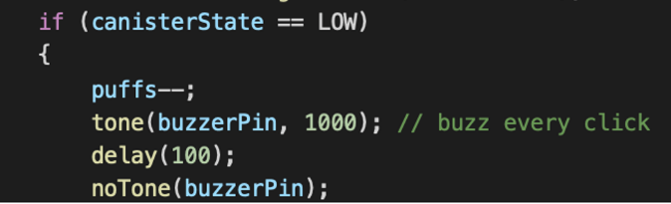

The fourth step involved the button’s if statement. If the button was pressed, we used the millis() function to keep track of the exact moment it was clicked. We used this to properly time how long the button was pressed down and to ensure that it could not be accidentally activated if it was quickly pressed in a bag or pocket. After 5 seconds, it would reset the puffs to the original amount and show a gradient on the LED, as well as buzz the piezo for 100 milliseconds to indicate that the resetting process had begun. Following this, it would run the SetPuffs function to allow the user the possibility of changing the capacity if they had switched to a smaller or larger inhaler. Lastly, it would buzz for another 100 milliseconds to signal that the reset was complete.

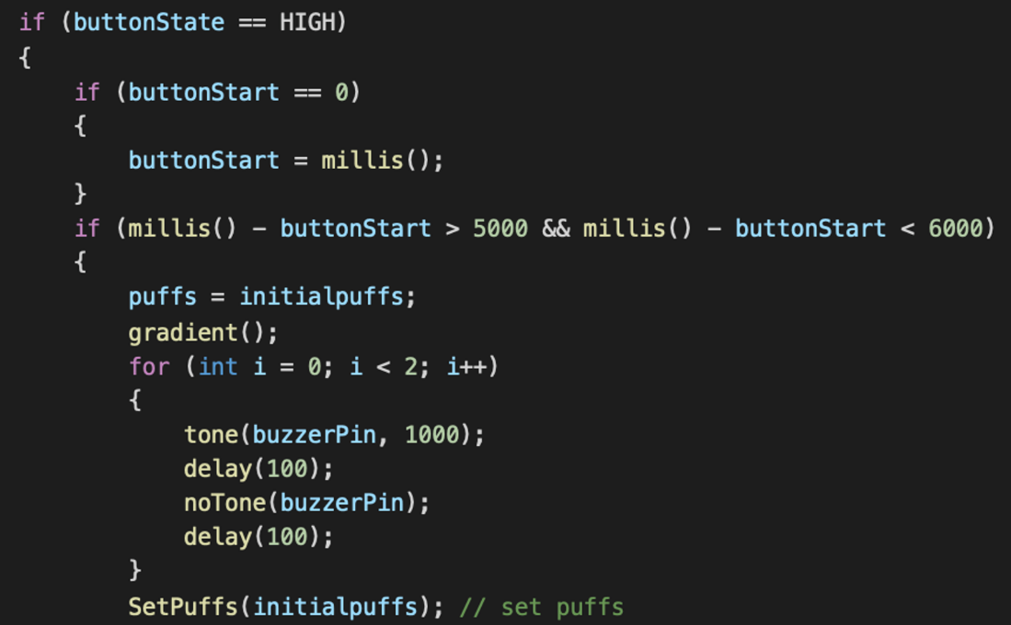

The fifth step was creating the visuals for the 8x8. The first two functions are “full()” and “rrows()”, which meant turning on or off the 8x8. These functions run a for loop for all rows and at row[i], “B11111111” and “B00000000” respectively. The way the 8x8 works is there are 8 rows with 9 chars within them, the letter B followed by either 1’s or 0’s meaning on or off, respectively. The x function does this similarly; however, I hardcoded the rows and numbers directly into an array to visualize the function and know exactly how it would be displayed in real life before even running it. Then, it would go through a for loop and run through that array, adding it to the board. The “half()” function does exactly what the “full()” function does; however, it only runs through 4 out of the 8 rows to turn half of the screen on. The last visual that was used was “gradient()”. This function essentially mixed the “full()” and “rrows()” functions into one and added a 100-millisecond delay between each row being added or removed so that it would be slow enough to visualize the gradient to the human eye. In the code, there was one more function that could be used if we expanded our market to all people. This is “updateDisplay()”. The premise of it is that it calculates what percentage you are at in your inhaler and displays that visually using the LED board. This starts by calculating your percentage and multiplies it by 8. In the final product, it is the percentage out of 20% total (e.g. 20% is 20 puffs, so 20/100 shows all 8 rows, 15 puffs show 6/8 rows, etc.). However, it could be done from the initial puffs depending on the market and desired goal of the product. After this, it goes through a for loop, and if the index it is currently at is greater than or equal to the total “rowsToShow,” it would display nothing for the row, and if it was smaller, then it would turn that row on.

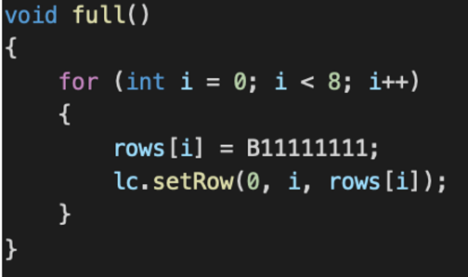

The last function we created was the "SetPuffs()" function, which was slightly mentioned earlier. This function is used for the user to declare what capacity they would like to change their counter to, or if they don't want to change it at all. First, it sets the total clicks and the holding time to 0. Then it starts an infinite while loop by reading the state of the button. Following this, it has four if statements. If the button is clicked and held for less than 350 milliseconds, it would count a click and set the buzzer off for 100 milliseconds, with another delay of 250 milliseconds after to allow for the release of the button. The second if statement checks if it is unclicked, and if that's the case, it continuously sets the button holding time to 0, allowing for the proper time of clicks and holds. The third and fourth functions are very similar. The third checks if the button has been held for 3 seconds and if the button clicks are at 1. If it were at 1 click, it means the user never changed the capacity and only held to finish the reset process. Because of this, it would reset the puffs to the original capacity, then turn the display on for 1 second to show the user it worked, and then end the infinite loop. The fourth function is the same, but the total clicks must be above 1. If that's the case, it would reduce your clicks by 1 to remove the extra one added when you start the 3 seconds hold. Then it would multiply your clicks by 50 and make that your new puff count, followed by turning on the screen for 1 second and ending the infinite while loop.

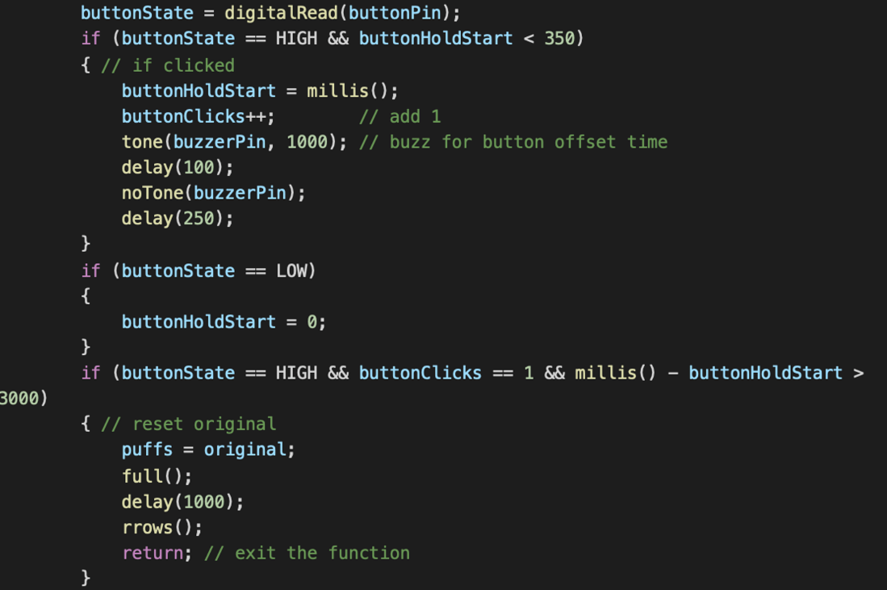

To see the full Code, see figures 12-16 in **(7.5)**

1. Our CAD design:

To place the electric circuits safely and in-order, we printed a case by building a CAD model and printing through PrusaSlicer. The case covers and attaches to the inhaler counter firmly with the electric circuits placed in.

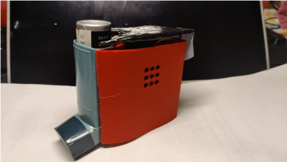The CAD module is built on OnShape and based on the original casing. The inner case which will cover the inhaler is created first. With the consideration of the thickness and a tiny gap to fit in, we created a sketch with the length of 2.89cm and width of 2.76cm **(Figures 3 & 4 of top and bottom views).** As the curvature on the inhaler counter is hard to measure, we created the curve parts with comparison.

We extruded the sketch with a height of 8.2cm based on the height of inhaler counter and shelled the solid to a thickness of 0.13cm. To make the case adjustable to the differet size of inhaler counter, the front part is extruded downwards 1.5cm, and a 1cm x 0.23cm square is drawn in the middle and extruded downwards throughout, so that the claps can be glued on the wall and make the inner case adjustable. The filter is also used to make the inner side more smooth. To create the back part of the inhaler counter, a 5cm long line is placed on the top surface. It has been extruded to a solid with a height of 8.2cm and shelled to a thickness of 0.25cm.

We built a frame support for battery. A 2.83cm x 1.65cm square is created in the sketch to fit the 9V battery base and is placed 0.835cm to the wall and 0.15cm to the inner case. The sketch of four frame supports can be seen on the image on the left. The sketch of the frame support composes two squares. The squares along the y-axis have a length of 0.5cm and width of 0.2cm, along the x-axis have a length of 0.7cm and width of 0.2cm. we then extruded upwards to create the frame supports with a height of 0.5cm. In the square for the base, a 1.53cm x 0.72cm square is drawn on the side away from the inner case and 0.65cm away from both sides for the charge port on the bottom of the battery. The square for the battery charging port is extruded downwards throughout.A picture containing text, wall, indoor, green
On the left side wall (from the front of the inhaler), we created a 1.2cm x 1.2cm square for the reset button which is 2.25cm away from the top and 0.85 from both sides. Then extruded by 0.25cm to create the window for the reset button (Upper left diagram). On the opposite wall, 9 circles with a radius of 0.4cm evenly placed as 3 rows and 3 columns. The upper row is 1.36cm to the top and the right-side column is 0.64cm to the edge. (Left diagram).

we created a 3.34cm x 3.25cm square based on the size of the light board. This square is 1cm away from the top and 0.33 from both sides and extrude 0.25cm to place the light board. (Lower left diagram)

The CAD module can is finished by those steps. To 3D print the module, we exported this part as the binary STL file with a fine resolution and used millimetre as unit. Prusa i3 MK3S & MK3S+ is the 3D printer used to print this project. After rotated to the right orientation, the CAD model is printed with the supports on “everywhere” and with 30% infill. The CAD model has a weight of 59.71 grams and had a printing duration of 7 hours and 52 minutes.

We also reduced the infill for the piece that surrounds the inhaler. This allowed the piece to flex, allowing us to accommodate slightly larger or smaller size inhalers. To see full images for the CAD drawings and the link, see figures 3-9 in **(7.2.2)**.

In our prototype the actual inhaler case is slightly longer than the printed module, but the sides fit very well. We decided to cut the walls in the front off and filed it down which makes the inhaler case fit perfectly. The window for the reset button was also filed to make the actual button fit.

1. Costs associated for each part:

|  |  |  |  |  |
| --- | --- | --- | --- | --- |
| **Name** | **Units** | **Cost/Unit** | **Total** | **Source (Hyperlinked)** |
| Casing (3D Printed) | 1 | $14.98 | $14.98 |  |
| Arduino Pro Micro | 1 | $15.99 | $15.99 | [Amazon](https://www.amazon.ca/ATmega32U4-Development-Microcontroller-Leonardo-Bootloader/dp/B07WPCLF8Y/ref=sr_1_4?crid=23NJU17M1KHFV&keywords=arduino+pro+micro&qid=1680129345&s=electronics&sprefix=arduino+pro+mi%2Celectronics%2C283&sr=1-4) |
| Wires | 10 | $0.13 | $1.33 | [Amazon](https://www.amazon.ca/Elegoo-120pcs-Multicolored-Breadboard-arduino/dp/B01EV70C78) |
| Button | 1 | $0.22 | $0.22 | [Amazon](https://www.amazon.ca/Gikfun-6x6x5mm-Switch-Arduino-EK1019C/dp/B06Y6DDG8K/ref=sr_1_5?crid=3S9BVJ10SBBJL&keywords=arduino+button&qid=1680129321&s=industrial&sprefix=arduino+butto%2Cindustrial%2C307&sr=1-5) |
| MAX 7219 8x8 LED | 1 | $14.41 | $14.41 | [Amazon](https://www.amazon.ca/ZYAMY-MAX7219-Interface-Single-Chip-Finished/dp/B07775NFS1) |
| Battery | 1 | $5.75 | $5.75 | [Amazon](https://www.amazon.ca/EBL-Rechargeable-Batteries-280mAh-Self-discharged/dp/B076Q89XT1/ref=sr_1_11?crid=32WCBXDHYPVOC&keywords=rechargeable+batteries+9v&qid=1680130028&sprefix=rechargeable+batteries+9v%2Caps%2C266&sr=8-11) |
| Charging Cable | 1 |  |  | Included with battery |
|  |  |  |  |  |
| Total |  |  | $52.68 |  |

Note: The battery we ordered was faulty, since it only held charge for around 3 hours and only charged on certain USB ports.

|  |  |  |  |  |
| --- | --- | --- | --- | --- |
| **Name** | **Units** | **Cost/Unit** | **Total** | **Source (Hyperlinked)** |
| Casing (injection molding) | 1 | $2.69 | $2.69 |  |
| Arduino Pro Micro | 1 | $3.48 | $3.48 | [Alibaba](https://www.alibaba.com/product-detail/Pro-Mini-ATMEGA328P-3-3V-8M_60421854886.html?spm=a2700.7735675.0.0.1b927f51H4l2le&s=p) |
| Wires | 10 | $0.13 | $1.33 | [Alibaba](https://www.alibaba.com/product-detail/Dupont-Wire-Male-To-Male-Female_1600231414826.html?spm=a2700.galleryofferlist.0.0.1fc11a8fTlyMrL) |
| Button | 1 | $0.22 | $0.22 | [Amazon](https://www.amazon.ca/Gikfun-6x6x5mm-Switch-Arduino-EK1019C/dp/B06Y6DDG8K) |
| MAX 7219 8x8 LED | 1 | $0.94 | $0.94 | [Alibaba](https://www.alibaba.com/product-detail/MAX7219-Dot-Matrix-Led-Display-8_1600583525386.html?spm=a2700.galleryofferlist.normal_offer.d_title.598b50dalxehqg) |
| Battery | 1 | $5.75 | $5.75 | [Alibaba](https://www.alibaba.com/product-detail/Best-Cheap-Lithium-Battery-With-Usb_1600770288676.html?spm=a2700.galleryofferlist.normal_offer.d_title.262143f9nI8fGI&s=p) |
| Charging Cable | 1 |  |  | [Alibaba](https://www.alibaba.com/product-detail/Factory-Wholesales-White-1M-3-3ft_1600526160436.html?spm=a2700.galleryofferlist.normal_offer.d_title.73eb78a8iNhvxs&s=p) |
|  |  |  |  |  |
| Total |  |  | $14.41 |  |

Here is the pricing list when we mass produce our device (for 1000 units). Here, our Arduino, casing and battery are much cheaper. For our case, we are planning to use injection molding, which will eliminate the need for 3D printing, allowing for cheaper and shorter manufacturing time.

Finally, to see an alternate view of the entire project summed up see **(7.7)**.

# Testing and Validation:

## Compliance Matrix: Constraints:

| **#** | **Constraint** | **Compliance Assessment** | **Rationale/Evidence** |
| --- | --- | --- | --- |
| 1 | Attention Grabbing  (Test example in 7.3) | Met | Effectiveness of sensory triggers (Volume and Brightness) and viewable distance from device (measured in m).  Visually tested by increasing distance from light and judging how noticeable light was from a head on view. We then tested with various angles and peripherals to make sure it was impossible to miss.  Audibly tested by changing the distance in a quiet room from the buzzer, as well as in a noisy park to make sure it was discernable over other noises. Overall, our finished prototype clearly complies and meets this constraint. Evidence is seen in (7.3) |
| 2 | Accurate counting  (Test example in 7.4) | Met | Physically count doses and track different set thresholds (number of doses)  We modified the code so that it signals each count with a sound, for better user feedback. We then simulated a max dose of 20 puffs, where only the last 5 puffs will notify the user. We tested the 20-puff limit multiple times physically counting the doses as well as modifying the time delay between the device registering another puff was triggered. Each test had a 100% success rate. During the showcase we didn’t want to simulate a 200-puff scenario; however, we believe that there will be <2% chance of a dose not being counted due to miscounts being triggered accidentally. In the grand scheme of 200 puffs, 2-4 missed calculated puffs will be an acceptable error range and will have a nearly negligible effect. This constraint is therefore, clearly met and is proven by the test in (7.4) |
| 3 | Non-disruptive process  (Test example in 7.4) | Met | Compare our concepts in controlled testing and have them rate how much the inhaler concepts disturbed them. (Measured from 1-10)  Our final prototype has absolutely no interference in the inhalation process. We add a coil to the bottom of the canister and some wiring to the bottom of the case and these two’s interaction provides no resistance or other effect on pressing the inhaler or inhaling a dose. Therefore, the user can comfortable and effortless continue to utilize their inhaler and this constraint is easily met as proven in (7.4) |
| 4 | Durable | Met | Taking the prototypes through a standard process of tests to check for durability (drop test, shake test, etc.). After each test, the prototype was ranked from 1-10. (Overall average will have to be over 8.5 to pass standard)  The new design passed the durability test by dropping it on the ground from waist height and chest height of all members and still being able to function properly, with minimal to no damages to the exterior casing. Additionally, we performed numerous shake tests where we attempted to simulate what may happen during transport of the product to our user. The test was performed by shaking the entire device for a total of a minute in all three dimensions and. The test was a success, and the Inhaler passed the shake test making it pass the needed standard and be a fulfilled constraint. |
| 5 | Portable  (Test example in 7.5) | Met | Concept needs to be able to comfortably travel in a small bag and be away from a power source for at least a week. (Will measured with a simple test to see if this requirement is met. Specific test includes running the prototype for a week without attempting to recharge it)  The final design has a similar size of an apple and has a weight of 80 grams which is like an egg. Due to this small size, it can travel in any sort of bag. We tested using a fanny pack and were able to insert and withdraw the inhaler with no issues. It is even able to fit into some larger pockets, however some smaller pockets may not be able to fit. This was officially testes in (7.5) by rating how well the final product fit into every dimension. Additionally, the inhaler was able to successfully last the seven days and not lose the ability to work due to a lack of charging. Therefore, the inhaler successfully passed this test proving that it can last a week without recharging. Overall, the final product clearly meets the needs of this constraint. |
| 6 | Electrically Safe | Partially Met | No exposed wires or any potential shocks to the user. (This will be measured by comparing concepts with electrical guidelines)  Although there is no electrical danger whatsoever in our design, our previous prototype had many wires that are where way too long, and as a result are tangled up and were pushed into the case. All these wires are insulated with each end/connection wrapped in electrical tape securely. To fully meet electrical guidelines and this constraint, we tried to remove this tangle of wires, and this is why our final product partially meets the constraint. The only reason we don’t fully meet the constraint is that we have not had a professional examine it. |

## Objectives Evaluation:

| **#** | **Objective** | **Evaluation** | **Evidence** |
| --- | --- | --- | --- |
| 1 | **Light weight:**  Inhaler counter should add minimal weight to the original inhaler | Met | Total design has a weight of 70 grams. The general type of inhaler counter on the market has an average weight of 50 grams. Therefore, 70 grams is slightly heavier than competition but is still very acceptable in weight. |
| 2 | **Easy to refill:**  Canister in the inhaler counter needs to be easy to replace by clients and can be replaced without much reliance on eyesight | Met | The process is almost as simple as the original steps. Originally, client will pull the canister out of the inhaler and put in a new filled canister. With our device there are only two steps added which require the client to pull out the canister and slip on a circular coil to the tip of the canister and to after putting another circular coil at the bottom of the inhaler. The two coils will come into contact when in use. Overall, these two steps making it extremely easy to refill. |
| 3 | **Simple electrical design for easy repair** | Not Met | A lot of the pieces had to be glued into place within the case itself, this makes it much more difficult to fix issues with the electrical components. On top of that there’s a lot of wired within the case and they get tangled up easily making it hard to see which wires go to different parts. |
| 4 | **Easy to recharge.**  Our users wouldn’t be able to use a complicated system, so ours must be simple | Met | To make the design easy to recharge, our final product and even our prototype has a large hole in the bottom for the charger to plug in. We use the same method of charging a phone to simplify the concept. |
| 5 | **Easy to manufacture:** | Exceed | The diagram of the CAD is easy to understand and even easier to print again. The assembly of electric circuit is straightforward and should not take very long. All the printing and assembling could be done in a short period of time. The code can simply be copied and pasted onto the processor, making this part of the assembly extremely fast. |
| 6 | **Client satisfaction:**  Clients find the new design useful and are willing to use it | Met | In our 3rd client meeting, we asked our clients via zoom how they felt about our light/buzzer system, and they enjoyed the simplicity and portability of our design, as well as the complete lack of interference for their inhalation process. The only aspect we have not confirmed physically is the exact size and feel of our inhaler, as our visually impaired clients can only learn so much in a zoom meeting and they unfortunately couldn’t make it to the showcase. |
| 7 | **Cheap to purchase:**  In the impaired eyesight community, many potential customers have a low income and cannot afford an expensive device | Met | Our estimated selling price is $50.00, with a project life of 5-10 years (guaranteed 5, expected 10). For an investment that will last our clients years, we feel that $50 is affordable for our target audience and has a reasonable unit contribution. |
| 8 | **Compatible with every (MDI) inhaler size** | Met | We have 3 designated sizes with given measurement ranges that any metered dose inhaler would fit under. In each inhaler case, we have something similar to a backpack strap that can be used to tighten our device onto the case so that it will fit snug and not fall out. |

# Comparison:

## Comparison 1:

**E-Dose Counter is an innovation design based on the general type of inhaler counter. It has an accurate counting sensor implemented in the inhaler and is attached with a small screen near the bottom of back side which could show the number of dosages left in the canister. E-Dose counter has yet to be manufacturing so it’s currently unavailable in the market. It’s more like a potential idea for the company Aptar.

<https://www.aptar.com/products/pharmaceutical/e-dose-counter-mdis/>

|  |  |
| --- | --- |
| Practicality Comparison | There is no posted price so we cannot compare cost. The E-Dose counter used sensor to monitor the remaining dosage, this technology exists but could be hard for mass production. 28Inhal’s design is more practical relatively. |
| Comparison of Strengths | The screen of E-Dose Counter is very small, and it will be very difficult for users with any sort of visual impairments. 28Inhal’s design used a large LED light board that can display obvious patterns with distinct sounds to remind our clients of the remaining dosages. |
| Comparison of Weaknesses | The counting system of E-Dose Counter is very accurate since they are using a sensor to track the remaining dosages. 28Inhal’s design will only give the clients a special reminder when there’s only a certain number of dosages left (below 20%), but not display for the remaining dosages will show before that threshold is met for 28Inhal’s design. Additionally, E-Dose Counter also has a relatively small size compared to our design. |
| Other Comparisons | There is no description about how long the sensor will last nor how to charge the sensor, so no comparisons can be made in this aspect. From the sketch of the E-Dose Counter, there is no access point for charging the sensor or making any replacements. That could also be a reason this product is still on hold to be in the market. |

## Comparison 2:

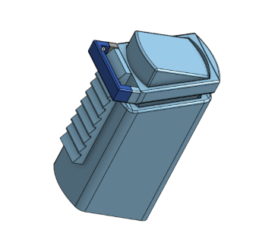 **28Inhal’s Inhaler Counter mechanical**   **prototype:**  Another solution we come up with is the mechanical inhaler counter. The sawtooth attached to the canister will be brought up one space by the ring every time user clicks it. And the user will know how much is left in the canister by feeling how low the bar has gotten compared to how many teeth are left.

|  |  |
| --- | --- |
| Practicality Comparison | Both 28Inhal’s mechanical and electric prototype needs some 3D printing work. However, for canisters with more puffs, such as 200, the 3D printed teeth will have to be extremely accurate and small, which greatly reduces the practicality of this idea. |
| Comparison of Strengths | 28Inhal’s electric prototype has a significantly friendlier model for counting, set-up, and adjusting. The electric prototype has a focus on being adjustable to every user’s needs. The mechanical prototype, on the other hand, is very specific to a set number of doses. This is still a strength of the mechanical prototype, as it can be made much smaller. |
| Comparison of Weaknesses | 28Inhal’s electric model’s size is a large weakness that this mechanical prototype has avoided. However, the mechanical prototype has an issue with travelling that we couldn’t be solved. The lever mechanism on the teeth can potentially be lifted and moved around accidentally. The electrical prototype has no issues with the count messing up as it is stored virtually. |
| Other Comparisons | Overall, the major discerning factor between the two is regarding the notification system to the user. Electrically, we have a light and a buzzer to notify via visual and auditory cues. Mechanically, however, we used touch as the sole sense to communicate information across to the user. Additionally, in the mechanical solution as well, there is no notification system that will notify when doses are running low, which is a major reason why the prototype was not advanced. |

# Potential Improvements

In the future, if we could do this project over again, we would have better researched our needed parts and ordered based on the best quality for the best price, instead of what would arrive the fastest. With this better research, we could have significantly reduced the size, complexity, and even increased the lifespan of our product using some or all the following potential changes:

1. Smaller wires: No matter what other changes are implemented; this is the most important by far. Using wires with a much smaller length and diameter will significantly clean up the design as well as simplify our electrical design, making it much easier for fixing or replacing any parts, as seen in objective #3 that was currently not met. This change also reduces all the tangled, exposed wires and can fix the partially met constraint #6 which is that it is electrically safe.
2. Using a better, lower voltage battery: A more reliable, longer-lasting battery will allow for longer times between charging. Our Arduino only operates at 5V so our current 9V battery isn’t necessary when 4 volts are being dropped. This can allow for us to use a smaller battery, as well as potentially include wireless charging using a 3.7 lithium battery, such as the batteries used in drones. Wireless charging is a great future improvement and will significantly ease the charging process for our visually impaired clients, relieving the stress of finding the charging hole and allowing them to simply place the inhaler on a large charging plate.
3. Replacing the Arduino with a smaller microchip. A smaller microchip would allow us to reduce the size slightly, as well as the price. A small microchip is much cheaper than an Arduino nano, however, the negatives of this change would be the process of programming the chip. We’d need specialized equipment to upload and write the machine code onto the chip.
4. A fourth and final change would be substituting our piezo buzzer for a programmable speaker. This speaker could expand on the auditory cues, giving an auditory description of the remaining doses rather than a couple of buzzes. This change would increase the price slightly and would most likely only be implemented in designs for the more significantly visually impaired.

# References

[1] “Digital dose counter for pmdi inhaler,” *Aptar*, 05-Apr-2023. [Online]. Available: <https://www.aptar.com/products/pharmaceutical/digital-dose-counter-inhaler-mdi/>. [Accessed: 06-Apr-2023].

# Appendix A – Examples of Design Documentation

## Flowchart

Figure 1: Flowchart of Circuit/Inhaler/code interaction

## CAD Models or Drawings

### Circuit Diagram

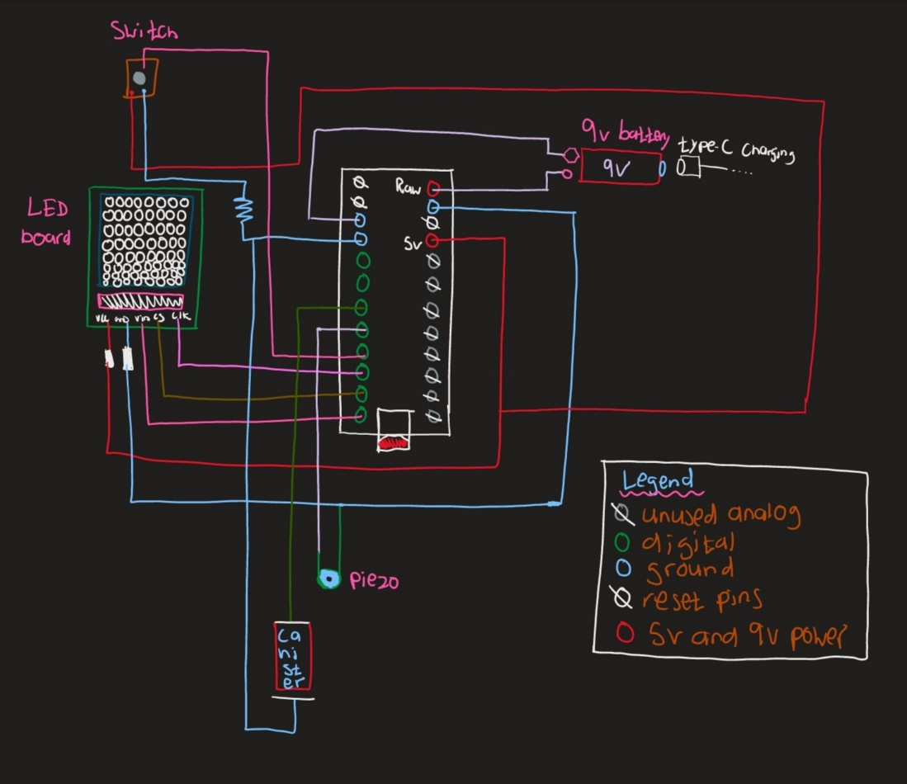

Figure 2: Circuit layout

### CAD Model:

OnShape Link: <https://cad.onshape.com/documents/bfd9272a384b0ac913500589/w/1d1537ef74912458f0b9a6d5/e/585b01d410b74e460a478d75?renderMode=0&uiState=641d9f9d4da6df4064047477&renderMode=0&uiState=642f281ed189e05afc98e762>

Figure 3: CAD bottom view

Figure 4: CAD top view

Figure 5: CAD Charging hole + Support Frames

Figure 6: CAD hole for LED display (Back)

Figure 7: CAD hole for button (Left)

Figure 8: CAD vent holes (right)

Figure 9: Prusa view

## Testing Results for “Attention Grabbing” Constraint:

These tests demonstrate that in both loud and quiet rooms you will easily be able to notice that the inhaler has buzzed and has notified you on the remaining dosages. Additionally, the light is very easy to see even from a far distance away.

Figure 10: Excel charts with Data conducted from two tests.

Figure 11: Graphs displaying the results from both tests.

## Video demonstration of “Accurate Counting” and “Non-disruptive process” Constraints:

Video Link: <https://photos.app.goo.gl/ZSRYMpd52zBB2q329>

This test shows demonstrates an un-interrupted inhaling process using multiple puffs and having no resistance or issues. It also demonstrates accurate counting with a first test run of 5 counts followed by a reset period and then 10 counts. The viewer can watch and clearly count along, seeing a 100% counting accuracy.

## Full code used for the prototype:

The following code is explained completely above in section 2b. Three things in the code were different from the explanation for presentation purposes, this was the initial puff count, the set puff function, and the canister delay. The initial puffs were set at 20 however in a real situation would be much higher (e.g. 250 puffs), and the set puffs function would increment by 25x or 50x the total button clicks to allow the user to reach their puff count much quicker. Lastly the release delay at the end of the canister if statement would be 3 seconds rather than 1 seconds.

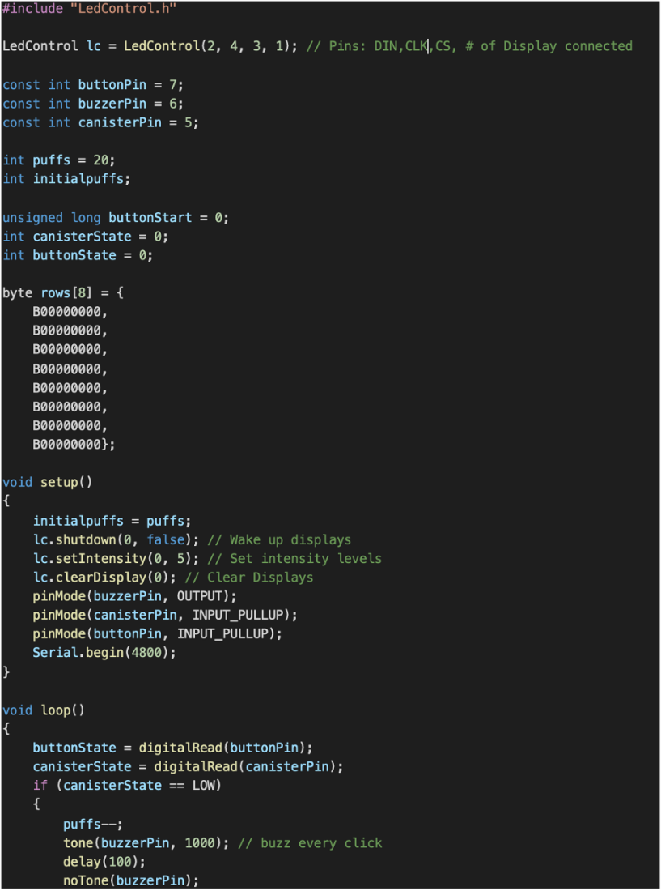

Figure 12: The initialization of the circuit

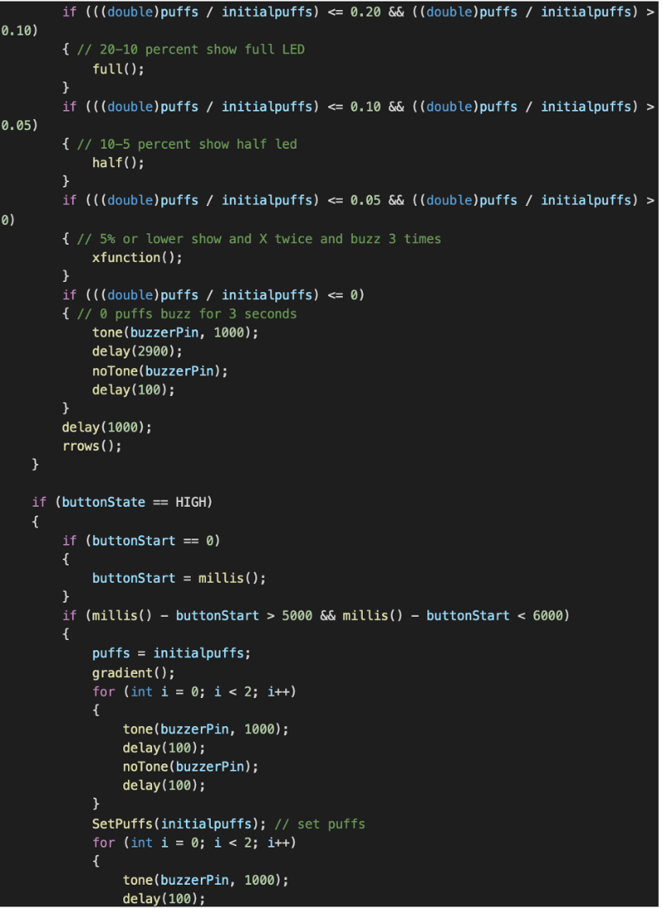

Figure 13: The canister and button functions



Figure 14: Functions for the 8x8 LED

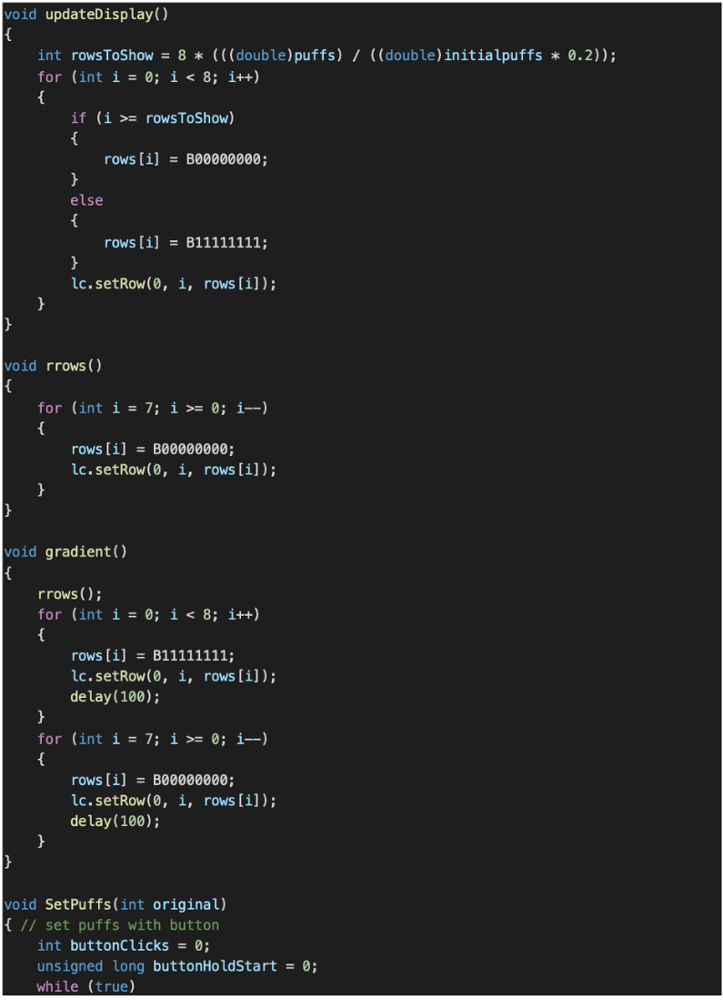

Figure 15: Functions for the 8x8 LED



Figure 16: The SetPuffs function

## Test For Portable Constraint:

This test shows that the inhaler is extremely portable for all sizes and only starts becoming unportable when attempting to store it in a carrying device that is either the inhalers exact size or only slightly larger.

Figure 17: Excel sheet containing data for portable testing.

## Poster Board:

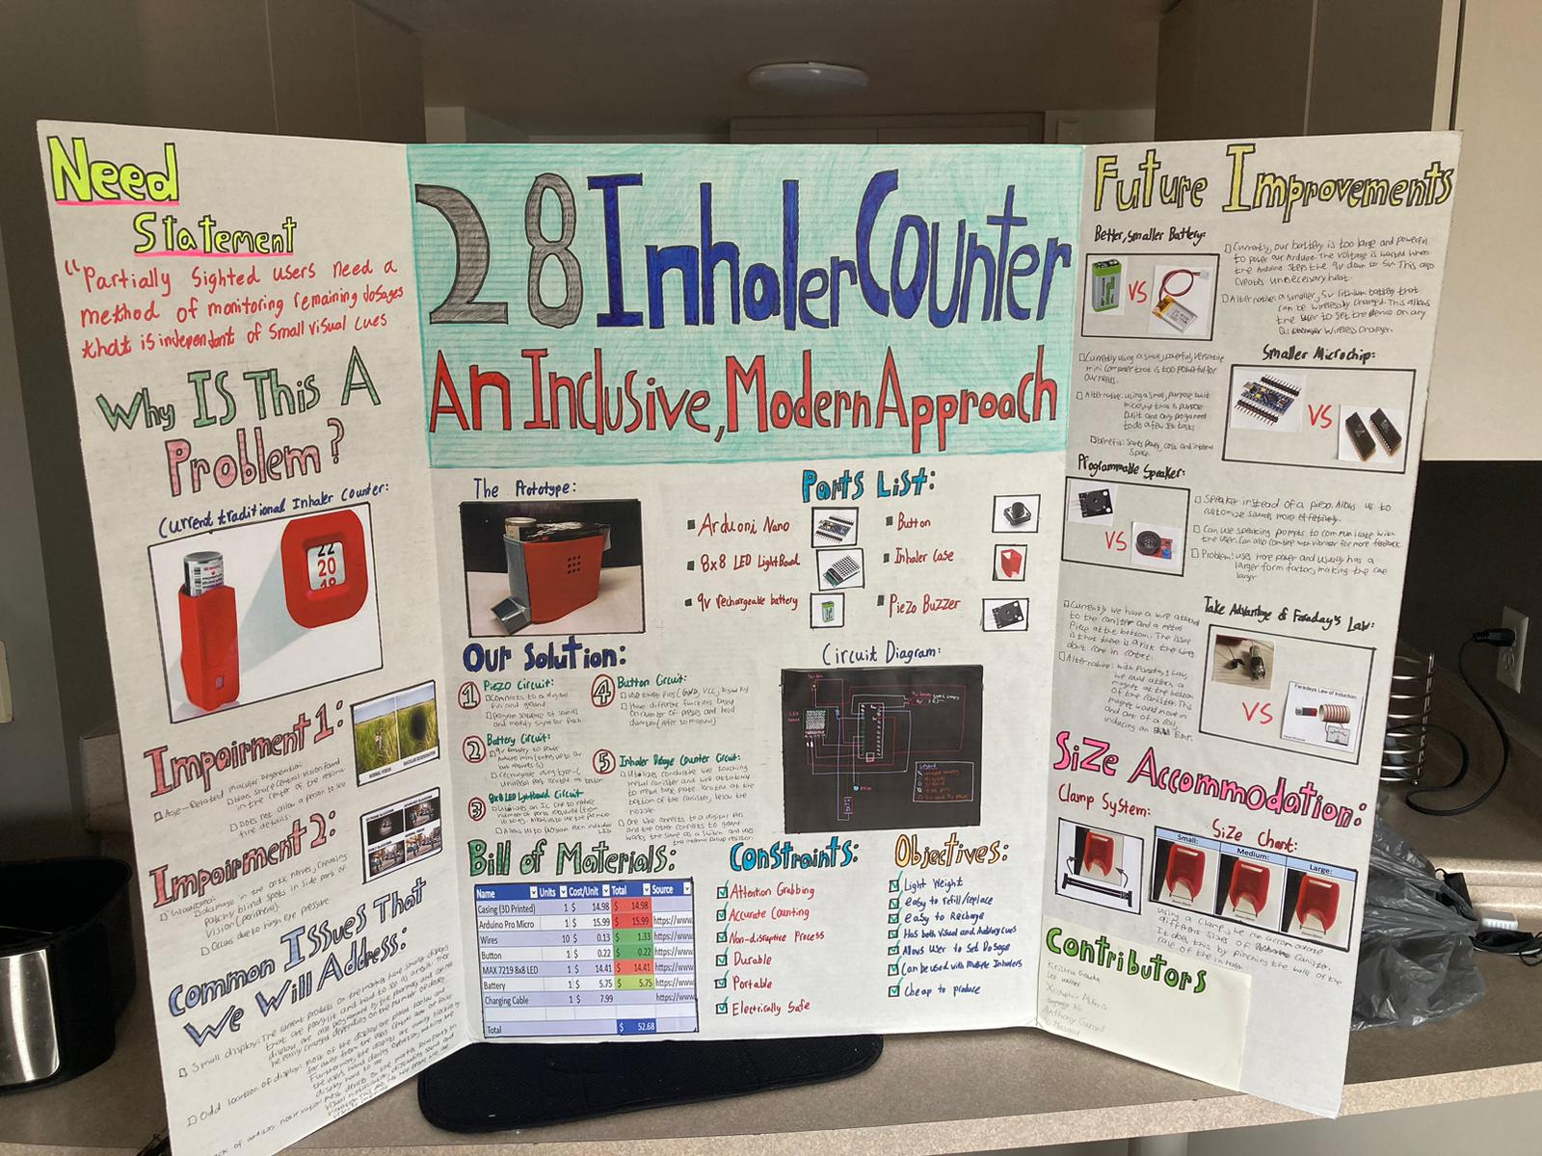

Figure 18: Here is our poster board. This includes our needs statement, our impairments, our issues and our solution.